This is the first in a series of articles that will be focusing on the ESVMG Gardens. Each month we will bring you a description of one of the lovely gardens that we have created and maintain. And, along with the description, we will feature one plant from this garden about which we will provide additional insight. Hope you enjoy the articles and are inspired to visit our gardens.

Bird Garden at the Chincoteague Wildlife Refuge
As I awoke the other day, I was greeted with the birds’ morning song promising the arrival of spring. This was a reminder that we have a responsibility to protect and nurture our environment so that these lovely creatures, who play an important role in our delicate ecosystem, continue to thrive. To do this, we must learn the plants and techniques to create wildlife habitats in our own backyards, however large or small they may be. And this is the goal of the Bird Garden at the Chincoteague Wildlife Refuge.

Located on the Chincoteague National Wildlife Refuge behind the Bateman Center next to the Butterfly Garden, this 1,000 square foot garden was created by Master Gardeners and Refuge volunteers in 2011. This year the Master Gardeners plan to extend the garden up to 3,000 feet and to replenish the existing garden.

A visit to this garden will show you some of the plants that play an important role in attracting and supporting the birds. These include Winterberry and Holly which provide winter food. The grasses found in this garden feed the birds in the fall and provide them with safe hiding and nesting places year-round. The garden also includes the native Wax Myrtle which grows naturally throughout the Eastern Shore and Mid-Atlantic region.

Wax Myrtle (Myrica cerifera) is a wispy, multi-trunked evergreen shrub which grows quickly to 15 or 20 feet high and wide. It goes by other names such as Southern Wax Myrtle, Candleberry and Southern Bayberry. These plants are either male or female, with only the female plants bearing fruit, so be sure to plant at least one of each. Wax Myrtles are durable and tough shrubs with no serious plant diseases or insect pests. They are very adaptable to different soil types, with a preference for slightly acidic soils, and grow best in sunny locations near wetlands, rivers and streams or sand dunes. They tolerate poor drainage and drought.

The fruit of the Wax Myrtle is a source of food for many birds, including Northern Bobwhite Quail, Carolina Wren and Tree Sparrow. And its fallen leaves are larval host of the Red-Banded Hairstreak butterfly (Calycopis cecrops).
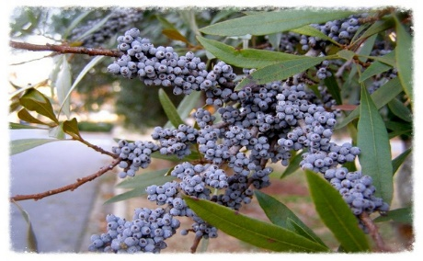
Wax Myrtles are used in gardens as screen plants or informal hedges and can be a native alternative to the undesirable Chinese privet (Ligustrum sinense) and Chinaberrytree (Melia azedarach). Their leaves are aromatic, with an appealing, piquant fragrance when crushed. The waxy barriers were used for making candles in colonial times. The plants were also used for medicinal purposes.
Here are some pictures from the garden:
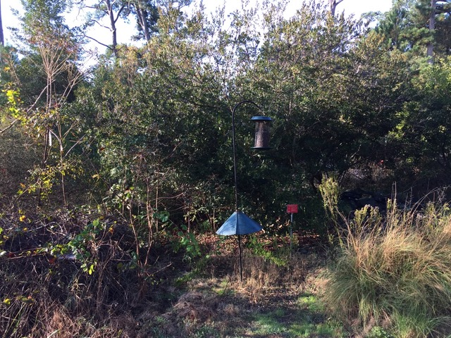
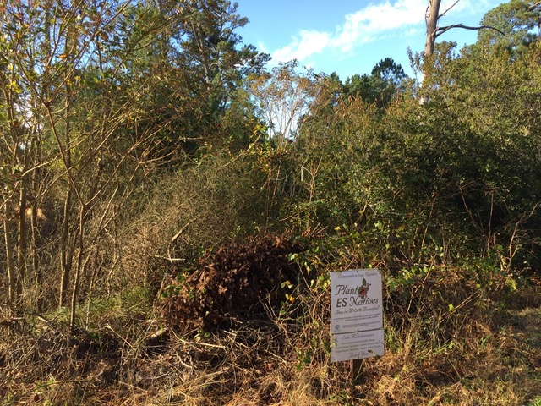
Birdfeeders are strategically placed to showcase some of the birds found in the Garden.
Brush pile for wildlife shelter
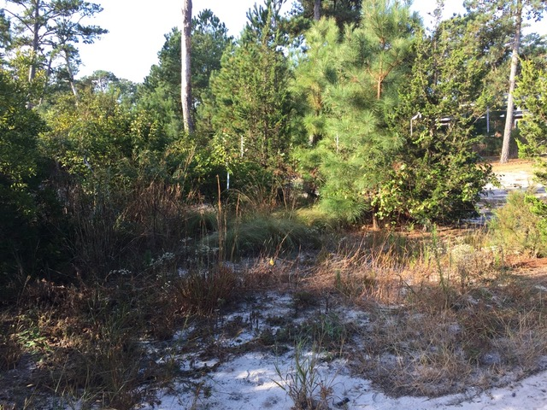
The garden offers many different growing conditions for plants. Which makes it interesting for many different backyard habitats. Sandy and wet soil, lots of sun or shade are just a couple.

